Homework 3

Anthony-22421378

1. **Introduction**

The goal of this project is to implement scene recognition using the concept of bag of features. The idea has been derived from the concept of bag of textures which is a popular and accurate technique used in natural language processing for classification of text into different category. In this model, a text (such as a sentence or a document) is represented as the bag (multiset) of its words, disregarding grammar and even word order but keeping multiplicity. In document classification, a bag of words is a sparse vector of occurrence counts of words; that is, a sparse histogram over the vocabulary. In computer vision, a bag of visual words is a vector of occurrence counts of a vocabulary of local image features. We use three ways of representing our images using appropriate features.

**2. Tiny images representation**

2.1 Code implementation:

Implementing Tiny Image

def tiny_image(image_path):

# Getting the size of image in path

n = len(image_path)

# the size of pixel in image for tiny image

size = 16

tiny_images = []

for image in image_path:

picture = Image.open(image)

picture = picture.resize((size, size))

picture = (picture - np.mean(picture)) / np.std(picture)

picture = picture.flatten()

tiny_images.append(picture)

return np.asarray(tiny_images)

Implementing KNN algorithm:

def euclidean_distance(x1, x2):

return np.sqrt(np.sum((x1 - x2) ** 2))

def knn_clasification(train_image, train_label, test_image, k=1):

predictions = []

for test_sample in test_image:

distances = [

euclidean_distance(test_sample, train_sample)

for train_sample in train_image

]

# Getting index of the nearest k neighbors

sorted_indices = np.argsort(distances)[:k]

# Collecting the labels of the k nearest neighbors

nearest_labels = [train_label[i] for i in sorted_indices]

if k == 1:

predictions.append(nearest_labels[0])

else:

predictions.append(max(set(nearest_labels), key=nearest_labels.count))

return predictions

Result of Experiment :

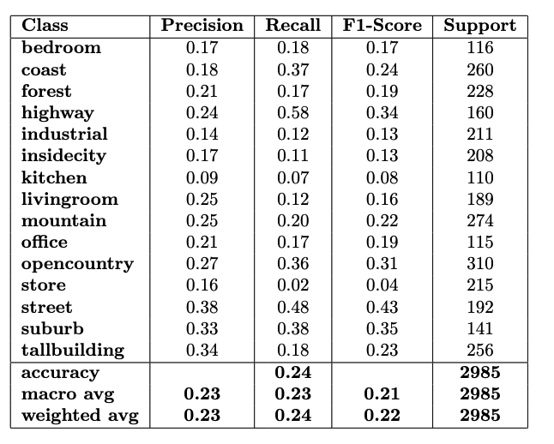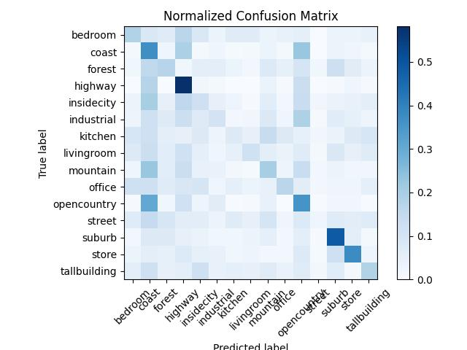

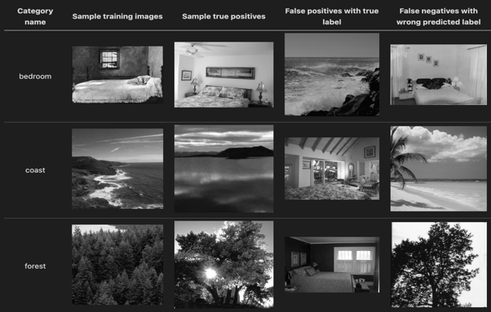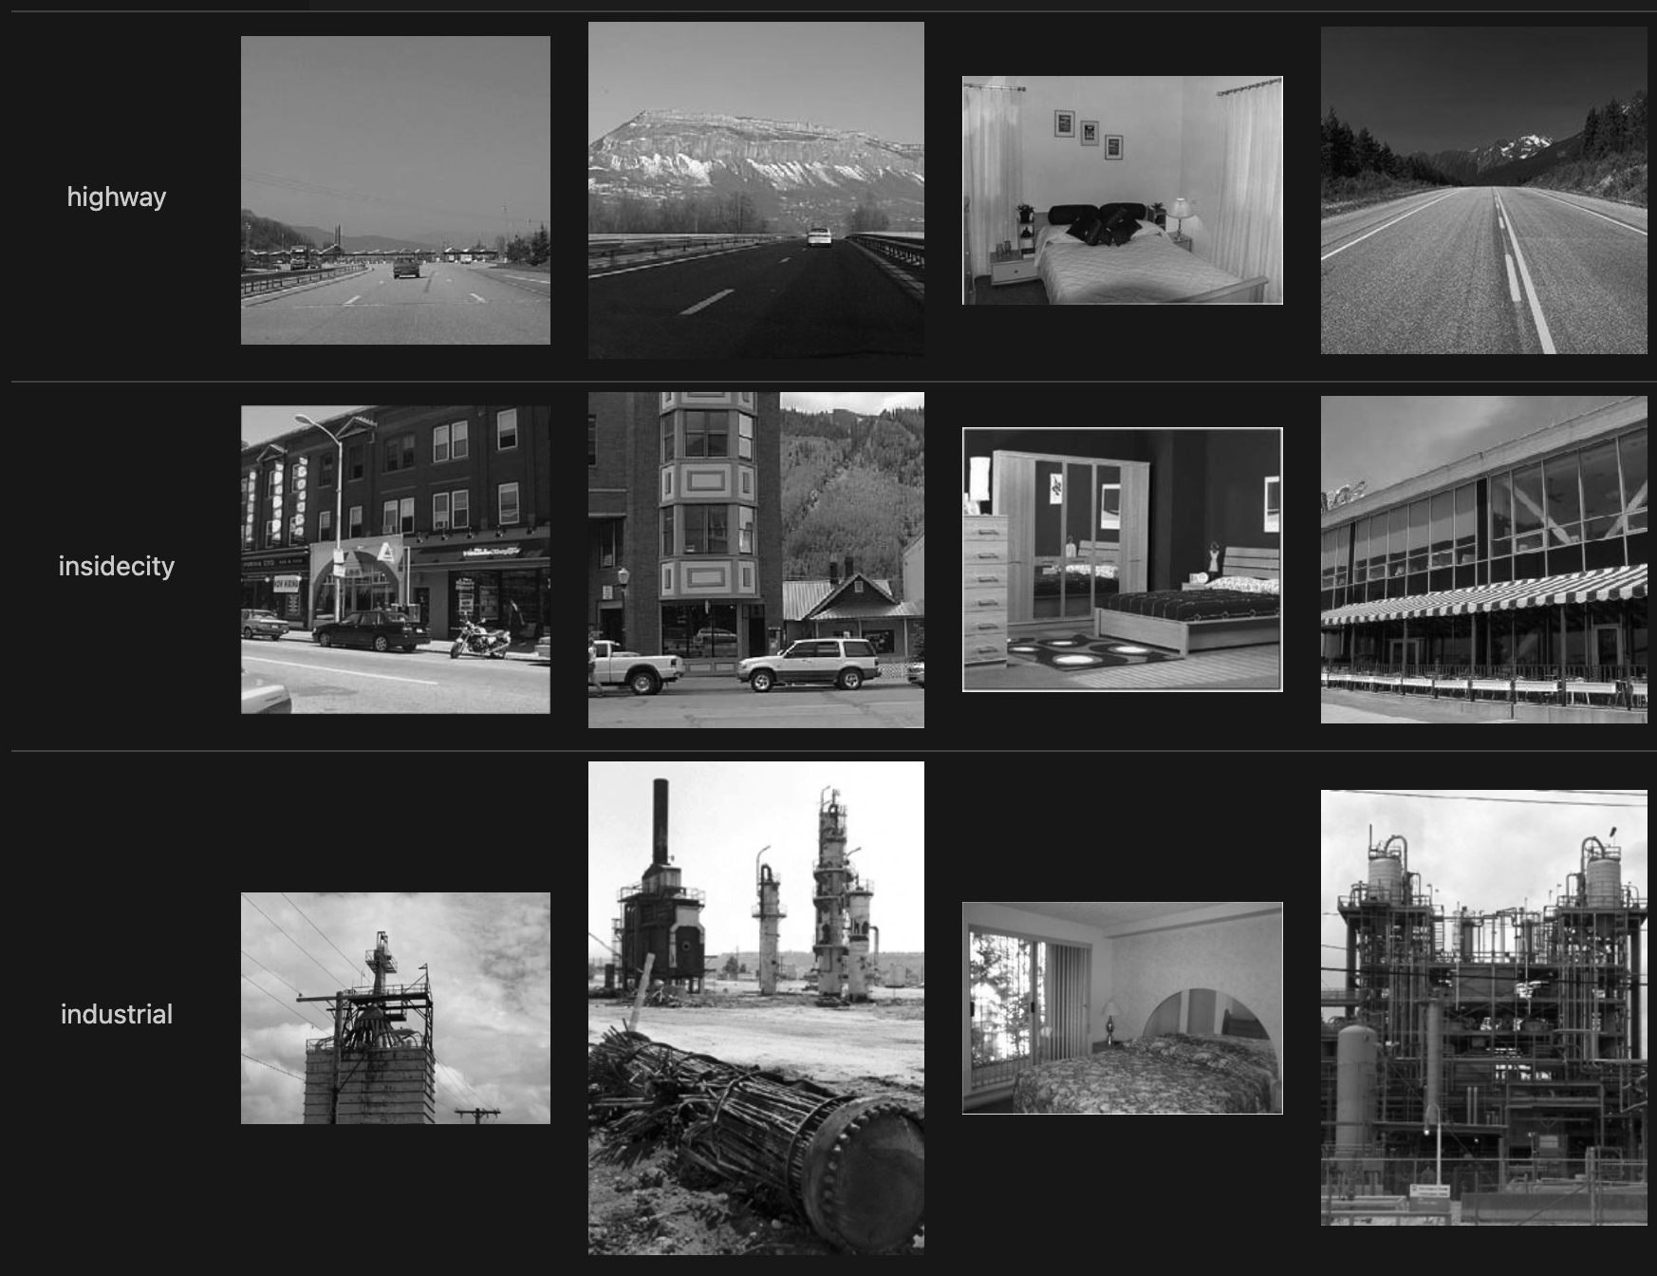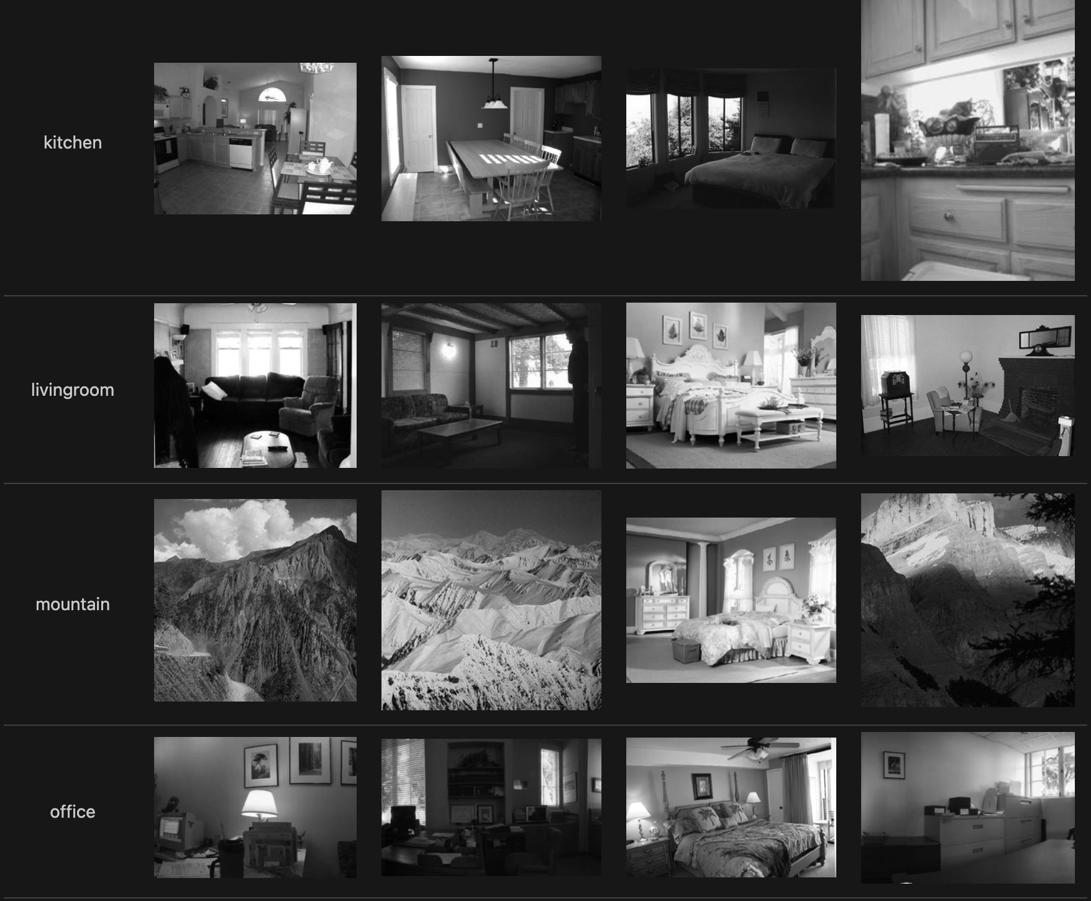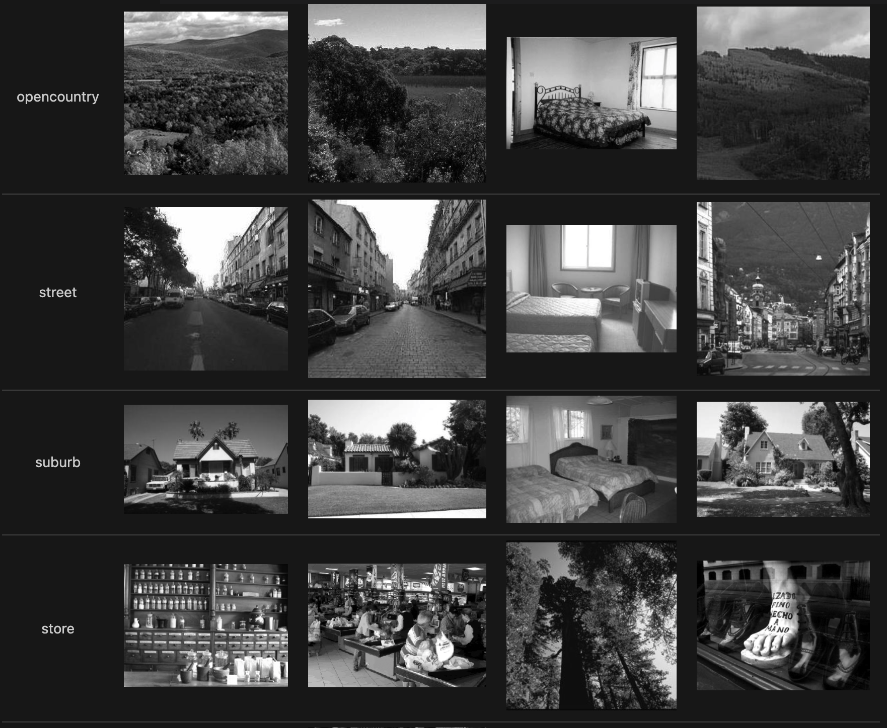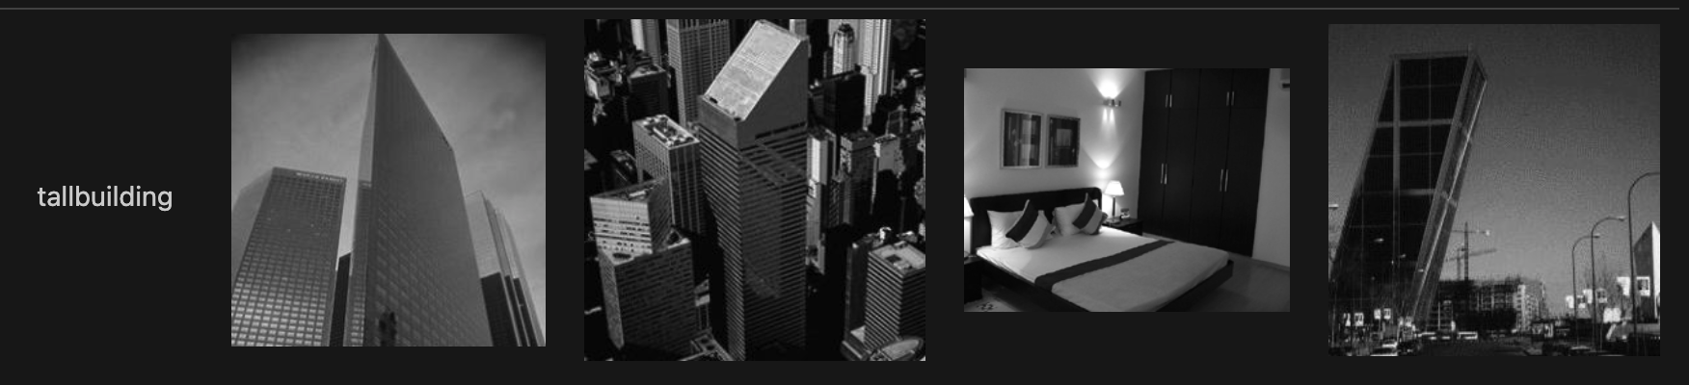

The result of this operation can be clearly seen in the tiny_image/visualization.md.

1. **Bag of SIFT representation**

**3.1 Building the vocabulary of visual words**

def vocab_build(image_paths, vocab_size, save_model_path="kmeans_model.pkl"):

sift = cv2.SIFT_create()

bag_of_features = []

for image_path in image_paths:

img = cv2.imread(image_path, cv2.IMREAD_GRAYSCALE)

keypoints, descriptors = sift.detectAndCompute(img, None)

if descriptors is not None:

bag_of_features.append(descriptors)

bag_of_features = np.vstack(bag_of_features)

try:

kmeans = joblib.load(save_model_path)

print("Loaded existing k-means model")

except FileNotFoundError:

print("Making a new model kmean")

kmeans = KMeans(n_clusters=vocab_size, random_state=0)

kmeans.fit(bag_of_features)

joblib.dump(kmeans, save_model_path)

print(f"Saved k-means model to {save_model_path}")

return kmeans

**3.2 Building the vocabulary of visual words**

def create_bag_of_sifts(image_paths, kmeans):

f_hist = []

for images in image_paths:

#using SIFT algorihtm

image = cv2.imread(images, cv2.IMREAD_GRAYSCALE)

sift = cv2.SIFT_create()

keypoints, descriptors = sift.detectAndCompute(image, None)

if descriptors is not None:

visual_words = kmeans.predict(descriptors)

# Create histogram of visual word occurrences

hist, _ = np.histogram(

visual_words, bins=np.arange(kmeans.n_clusters + 1), density=True

)

# normalize histogram

hist_norm = [float(i) / sum(hist) for i in hist]

f_hist.append(hist_norm)

image_feats = np.asarray(f_hist)

return image_feats

**3.3 Nearest neighbor classifier**

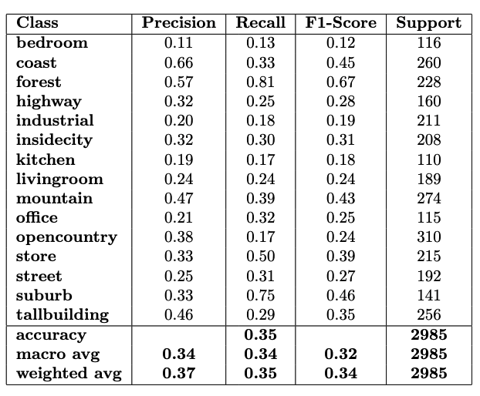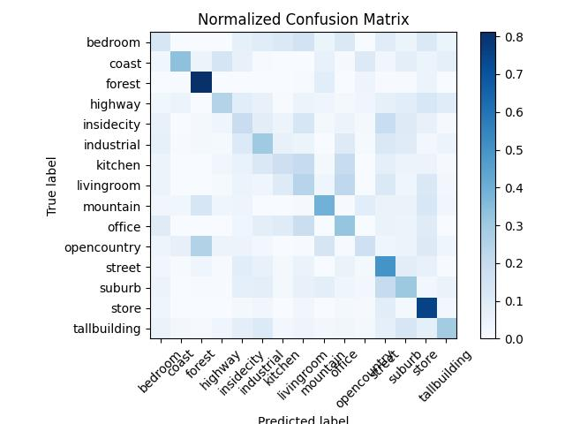

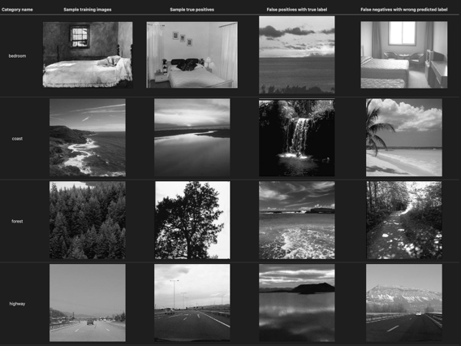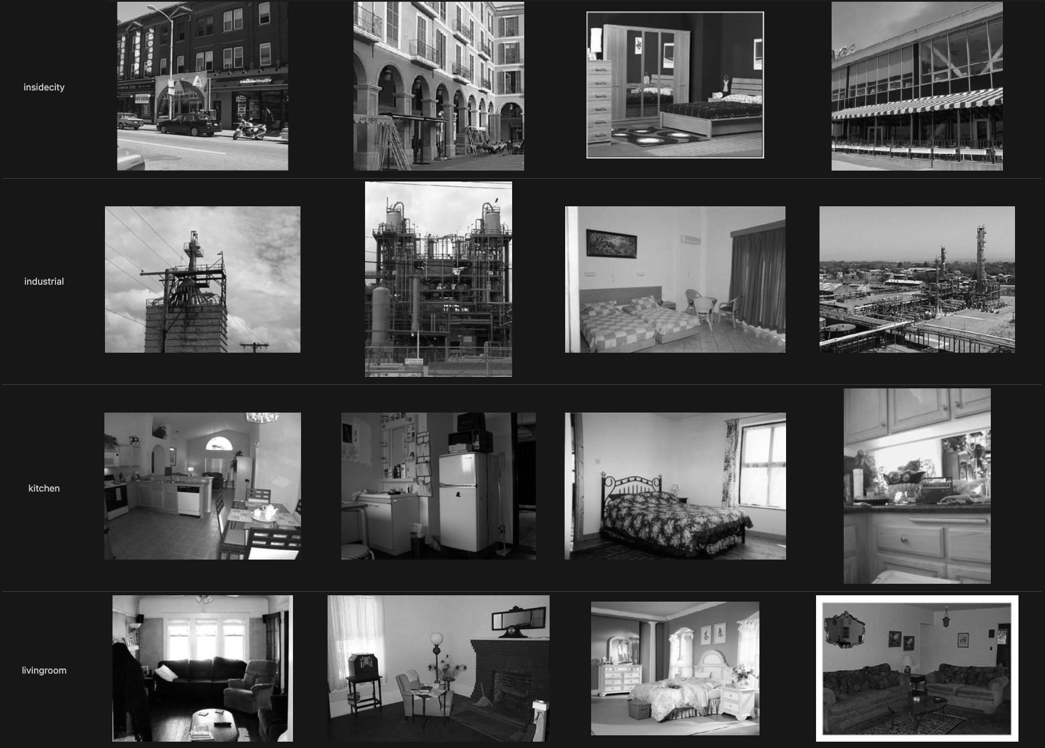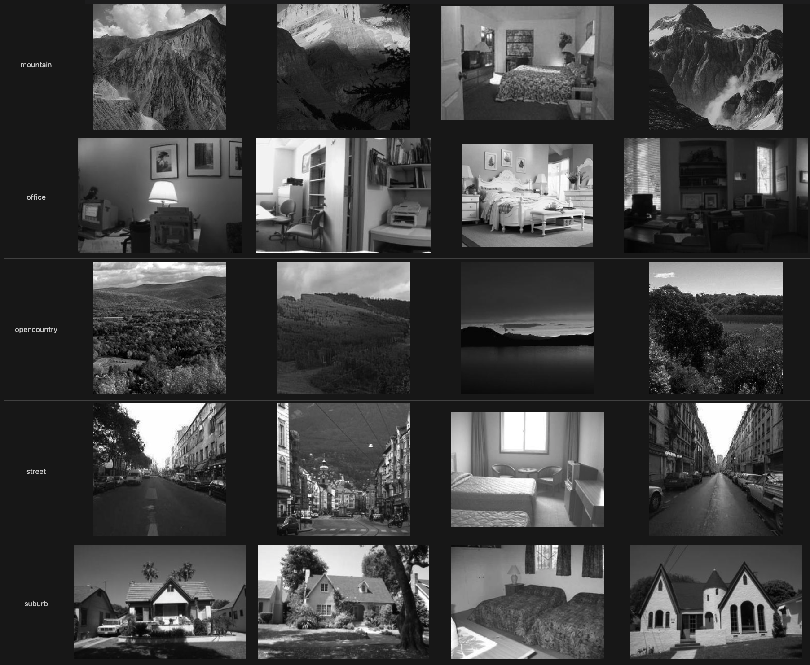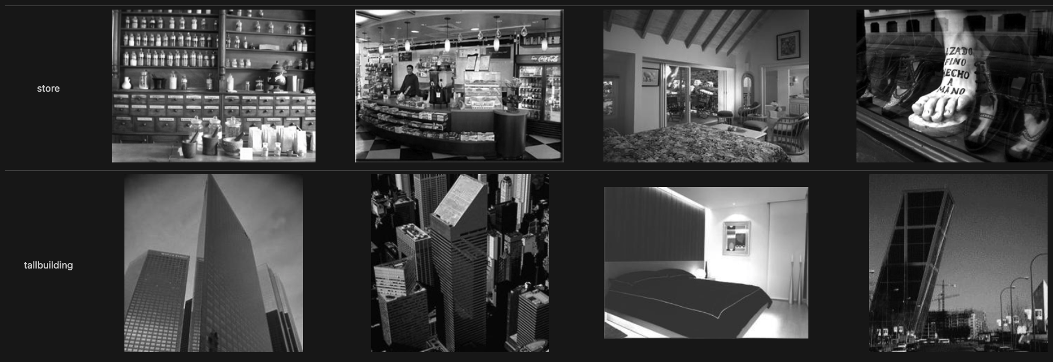

The result of this operation can be clearly seen in the bag_word/visualization.md.

**3.4 Comparison**

|  |  |
| --- | --- |
| **Parameter (K)** | **Accuracy** |
| 10 | 22.75% |
| 20 | 29.92% |
| 30 | 32.16% |
| 40 | 35.61% |
| 50 | 34.27% |
| 60 | 35.44% |
| 70 | 34.74% |
| 80 | 35.24% |
| 90 | 34.94% |
| 100 | 36.34% |

**Discussion**

Considering that vocabulary size is one of the important factors affecting the performance in this bag-of-words scene recognition experiment, we can see that a reduced vocabulary captures fewer details and can be said to be underfitting, while an enlarged vocabulary captures more details with higher computational cost and risk of overfitting. Empirically, a proper trade-off can be established. I think it is more reasonable that with better feature recognition accuracy, better dimensionality reduction methods or better advanced classifiers such as SVM or deep learning can be optimized for this problem.